Reception week 1
Remember to try and be resourceful when needing to use equipment. A ball could be made from socks. A blow-up beach ball, beanbag, pillow, pillowcase with some clothes in it, plastic bag with some socks in it, washed out milk container could be used instead of a tennis ball, soccer ball, netball etc.
Learning Intention: Students will practice catching various sized balls
Success Criteria: Student can track and try to catch various sized balls

Concept of Focus – Catch
The ability to catch a ball is vital to play most ball games such as baseball, basketball, netball, and cricket, as well as many playground games. Plenty of opportunities and time to play with balls is important.
Parent/Caregiver notes
• Don’t combine catching with a throwing. Children learn to catch with a large ball and throw with a small ball.
• Children need lots and lots of practice and experience with balls so they can make an accurate judgment about the way balls move.
• Ensure a child is not looking into the sun when trying to catch a ball.
• Balls and background colours should contrast.
Introduction
Language for lesson – Some of the key word’s parents/caregivers might use when playing catch
Watch the ball
Eyes on the ball
Soft fingers Reach to the ball
Make a net/cup

Warm-up
Get your mind and body ready for PE – use the link below
https://www.youtube.com/watch?v=Ki8haFw_YlA
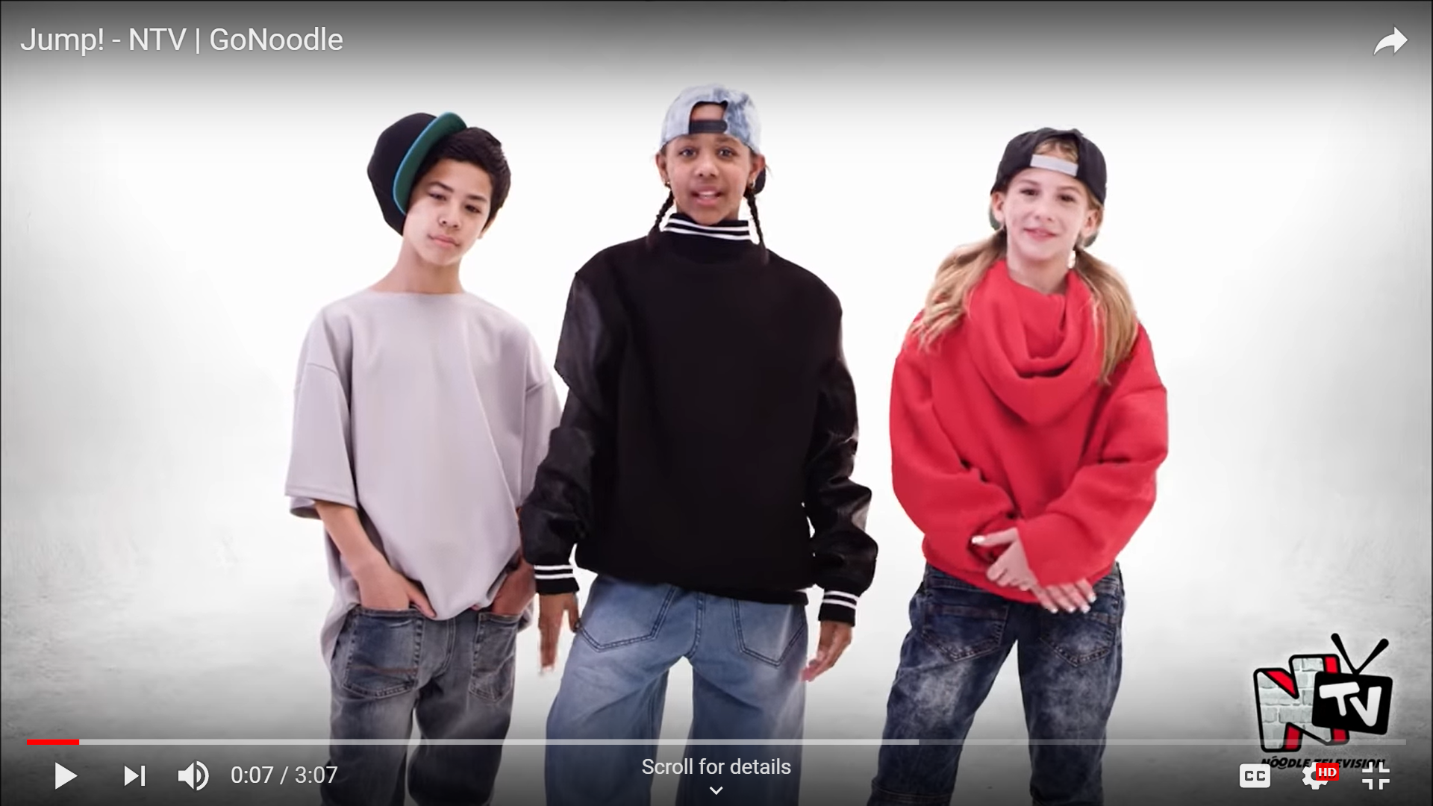
Development – complete these series of tasks to develop your catching skills
Modify equipment to use what you have at home
Catching activities below are suggestions. Make up your own catching games if needed. Modify equipment and people involved in the activity to what is available at home. Bean bag could be a sock ball, tennis ball etc.
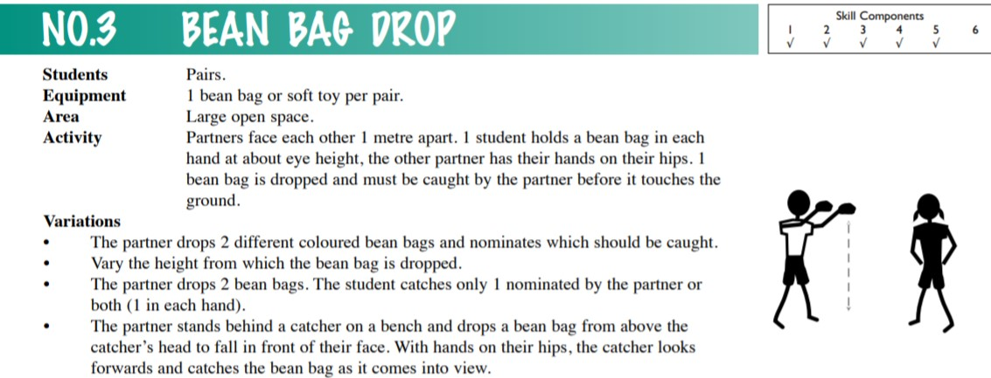

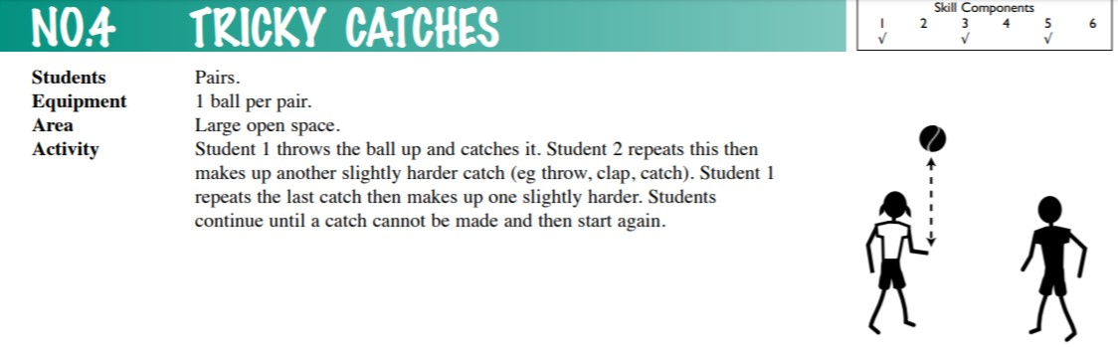

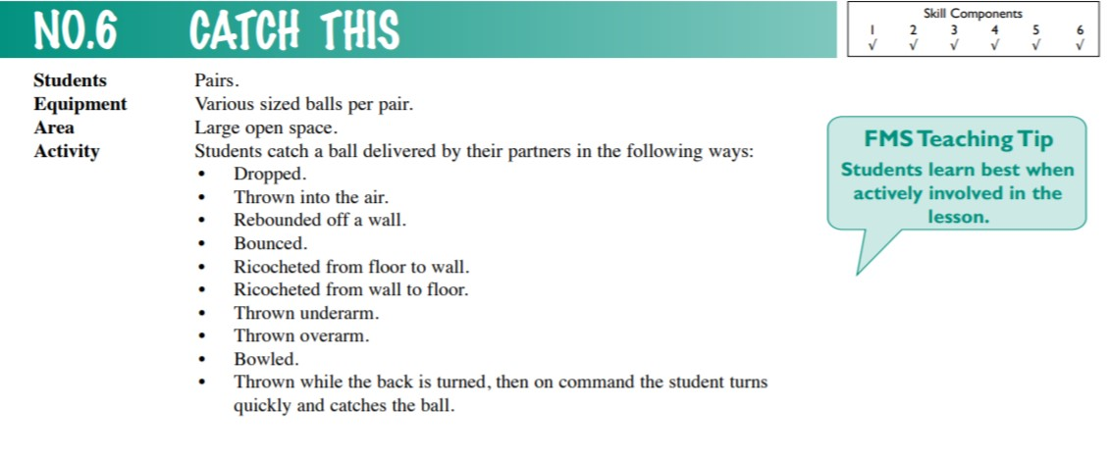

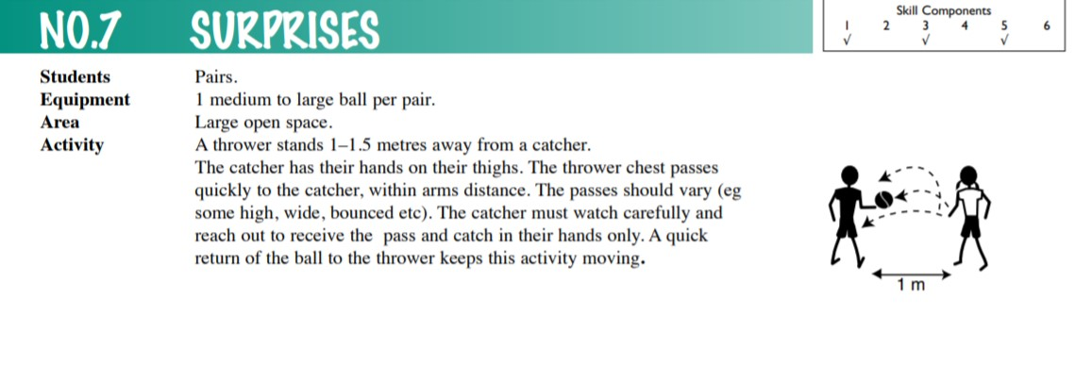

Self-Reflection
What did I learn today?
What did I do well?
What could I improve on?
How could I use catching at school or on the weekend?
Any questions for the teacher?
Teacher Led
How do I feel about my learning today?
Thumbs Up – Feel great about it
Thumbs Sideways – Feel ok about it
Thumbs Down – Don’t feel good about it

