Remember to try and be resourceful when needing to use equipment. A ball could be made from socks. A blow-up beach ball, beanbag, pillow, pillowcase with some clothes in it, plastic bag with some socks in it, washed out milk container could be used instead of a tennis ball, soccer ball, netball etc.
Learning Intention: Students will practice underarm throw
Success Criteria: Student can underarm throw at a target

Concept of Focus – underarm throw
The underhand or underarm throw is useful for short distances, particularly when accuracy is important, for example in a run-out in tee-ball. It is used in several games and is the only throw permitted for a softball pitcher to the batter. A similar action is used to serve in volleyball and badminton. The same skill criteria are important for the underhand roll, except the ball is released along the ground by bending the knees and leaning forward. The underhand roll is used in tenpin bowling and in rolling a hoop or a tyre.

Parent/Caregiver notes
• The underhand roll is a similar skill except the performer needs to bend their knees more. If the ball bounces along the ground, then they need to bend their knees even lower.
• Consider using different size balls to vary the difficulty of the activity.
• This skill doesn’t need to be taught before the overhand throw. They are different ball skills with different skill criteria.

Introduction
Language for lesson – Some of the key word’s parents/caregivers might use when playing

Step, swing, follow through

Opposite foot forward

Warm-up
Modify equipment to use what you have at home
Modify equipment and people involved in the activity to what is available at home. Bean bag could be a sock ball, tennis ball etc.
Use a box bucket instead of a hoop
Sock balls or empty containers instead of bean bags
Use your underarm throw when playing this game

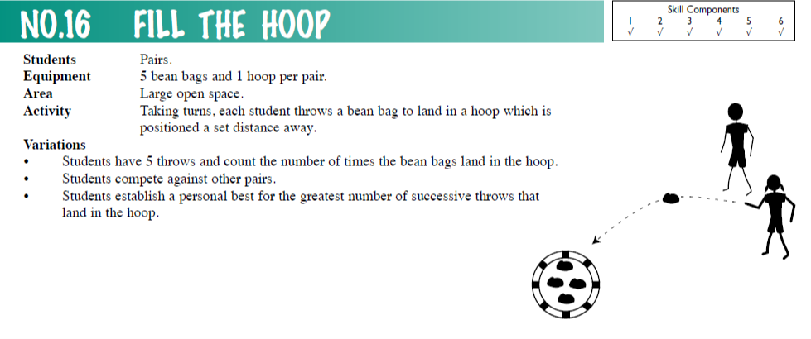

Development
Modify equipment to use what you have at home
Modify equipment and people involved in the activity to what is available at home. Bean bag could be a sock ball, tennis ball etc.
Use your underarm throw to hit the target
1.Bullseye
- Set up a playing area that has a ‘throwing line’ 3 metres from the targets (3 buckets in a line small, medium big, could be 3 plates, small medium or large)
- Players throw the ball/object towards the target and tries to land the object in/on the target.
- Create a scoring system so that the hardest target to achieve is worth more. eg. small 5, medium 3 and big 1 point.
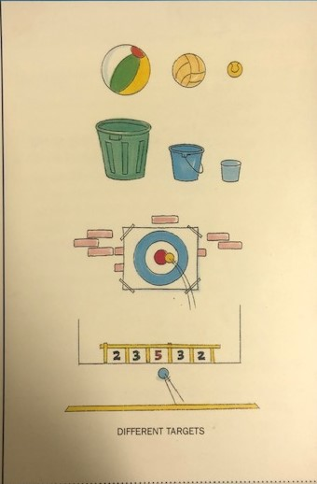
- Play until a player earns 20 points.
Change the game
The distance from the throwing line.
The size and shape of throwing object.
Make the target size bigger/smaller

Questions to ask
Will your throwing technique change for a wall target?
What change can you make if the object goes too far/too short?

2. Skeet
Use the underarm through to play
Skittles could be empty plastic containers, buckets, boxes, soft toys
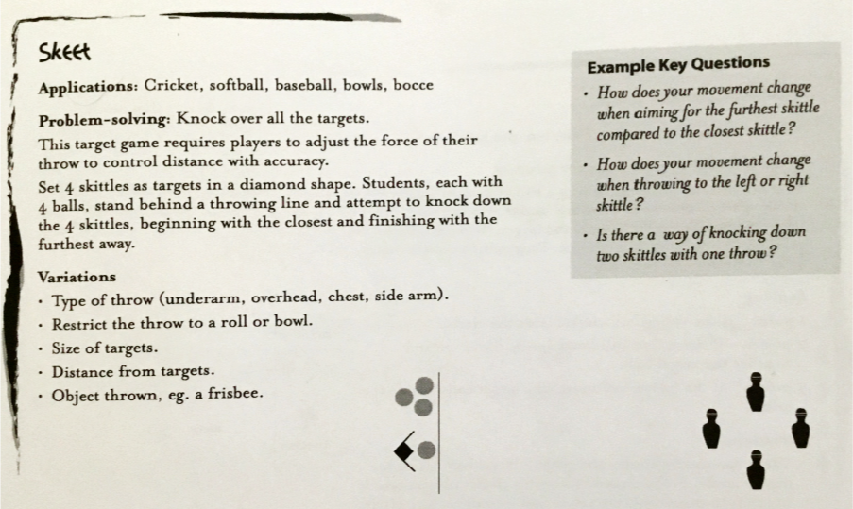

Self-Reflection
What did I learn today?
What did I do well?
What could I improve on?
How could I use catching at school or on the weekend?
Any questions for the teacher?
How do I feel about my catching today?
Thumbs Up – Feel great about it
Thumbs Sideways – Feel ok about it
Thumbs Down – Don’t feel good about it

