Year 3/4 PE Lessons - Monday

Learning Intention: To understand that a target game requires a player to send an object away to hit a target, using an overarm throw

Success Criteria:
- Set up a target
- Choose suitable objects to hit the target
- Use throwing action when sending the object away

Parent/Caregiver Information:
Target Games are activities in which players send an object toward a target while avoiding any obstacles. By playing these games, participants will learn the key skills and strategies for games such as Croquet, Golf, Archery, Boccia, Curling, Darts, Pool/Snooker/Billiards and Bowling.

Academic Language for lesson
Accuracy
Aiming
Hit a target

Introduction:
Warm up – Arrow
Set up a firing line and some targets along a wall/fence line. Remember, use what you have at home. Do not need to use equipment suggested, change and use what you can.
From behind the firing line, throw the object at the target.
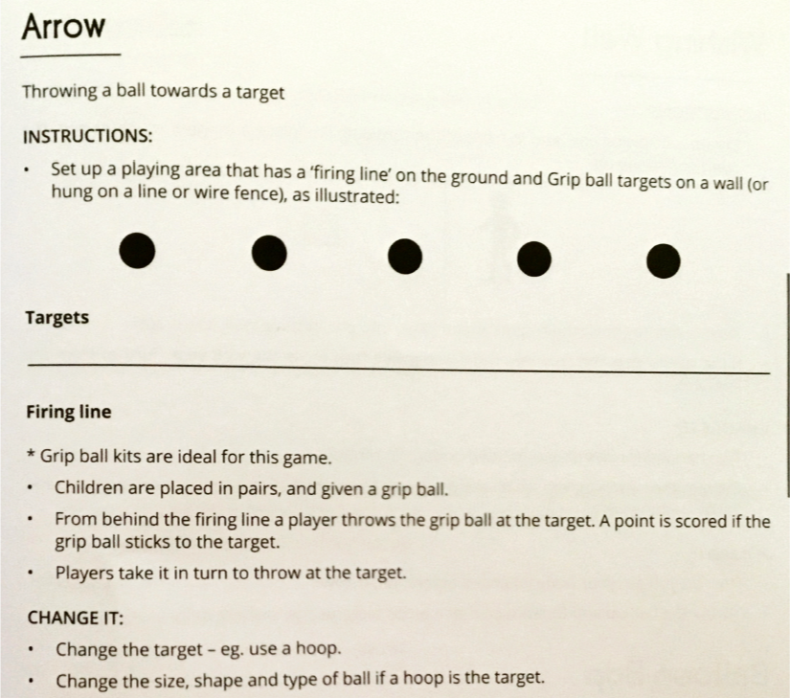
Change the distance of the firing line. Play the game with 5 different firing line distances.

How can you change the game but still use the overarm throw?
Try adding some extra challenges to the game
- You could put an object, like a chair in the way of the target – how can you get to the target with an object in the way
- Make the object you are throwing bounce then hit the target
- What other ways could you make it a challenge to hit the target?
Questions to ask
Did my accuracy improve once I checked how my overarm throwing was going?
Am I more accurate closer or further away from the target?
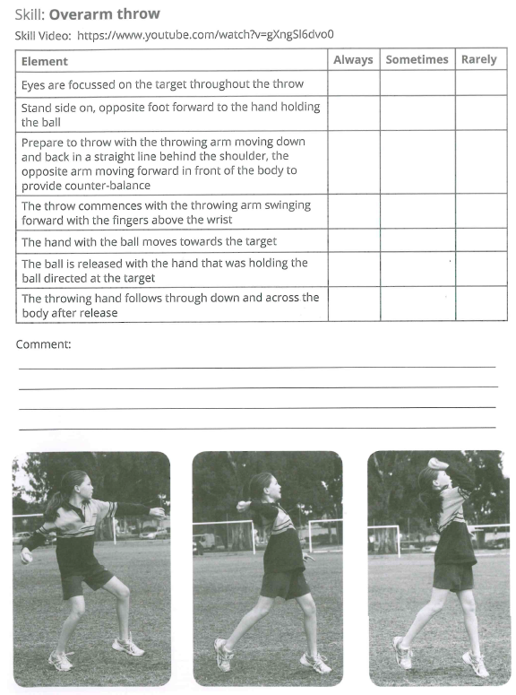

Reflection:
What did I learn today?
What did I do well?
What could I improve on?

How could I use ________________ at school or on the weekend?
Look at your Teaching for Personal and Social Responsibilities levels and rate what level you were working at today? These are a bit different to at school, so read them carefully before choosing your levels (Remember you can be on more than one level)
Was it level 0,1 ,2, 3 or 4?

