Year 5/6 PE Lesson

Learning Intention: To understand that a target game requires a player to send an object away to hit a target

Success Criteria:
- Set up a target
- Choose suitable objects to hit the target
- Use throwing action when sending the object away

Parent/Caregiver Information:
Target Games are activities in which players send an object toward a target while avoiding any obstacles. By playing these games, participants will learn the key skills and strategies for games such as Croquet, Golf, Archery, Boccia, Curling, Darts, Pool/Snooker/Billiards and Bowling.

Academic Language for lesson
Accuracy
Aiming
Hit a target

Introduction:
Warm up – Arrow
Set up a firing line and some targets along a wall/fence line. Remember, use what you have at home. Do not need to use equipment suggested, change and use what you can.
From behind the firing line, throw the object at the target.
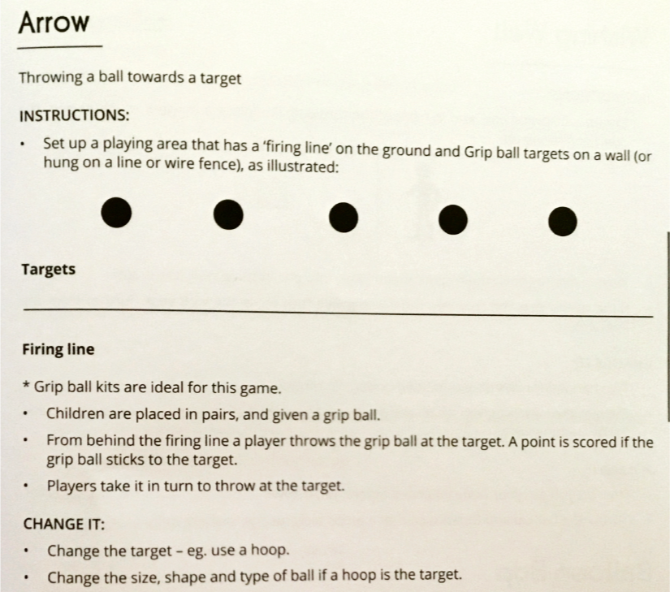
Change the distance of the firing line. Play the game with 5 different firing line distances.

Development:
Game
1 – Throw Archery
Set up 5 different point scoring zones (use sticks, draw lines, lay down skipping ropes or rope)
Choose three different objects to throw underarm.
Choose a starting point at least 5 giant steps away from targets.
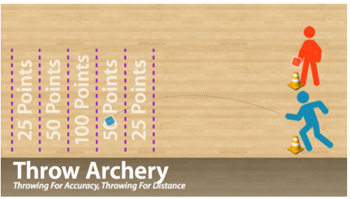
Throw underarm and add points together. If competing with someone, see who wins the round, by scoring the most points
Repeat moving the starting point closer or further away.
Questions to ask yourself from the game
How do you get the objects to land in a high-scoring target zone?
How does throwing from closer/further affect your throw?

2 If you have a device to record your underarm throwing for accuracy, record yourself throwing at a target and use the checklist to see if you are throwing underarm correctly.
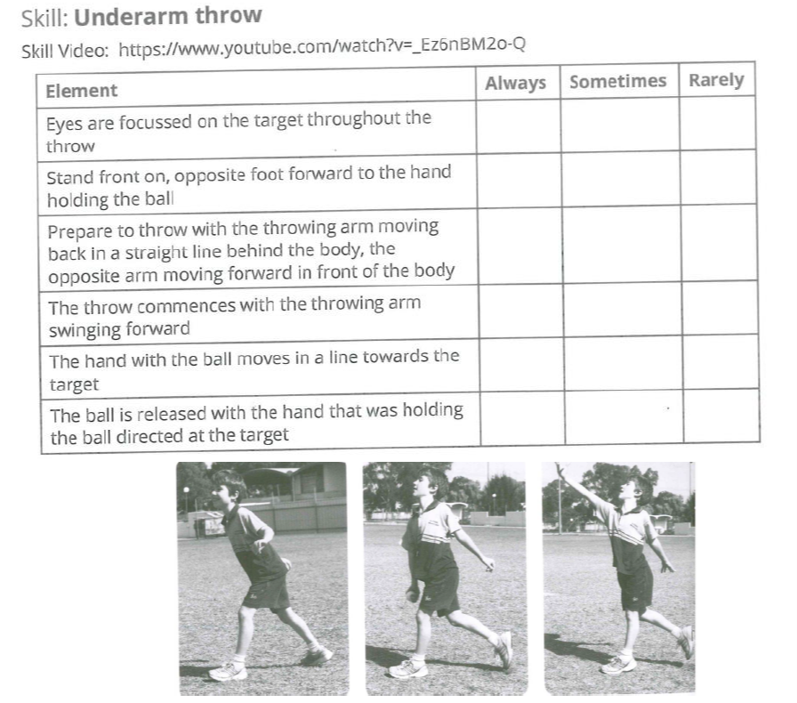

3 Bean Bag Bocce – Use any throwing materials you have at home. Sock balls, empty milk containers, tennis balls, cushions, soft toys, bottle top lids etc.
(Got someone else at home who wants to play?)
More than one player Divide into teams.
Each team is given four objects to throw (if possible all of the same colour) and one very different object (which will serve as the pallino).
Teams decide which team will throw first. Use rock, paper, scissors if cannot decide.
The starting team throws the pallino object.
The first player from that team throws their object trying to get it as close to the pallino as possible.
The second team’s first player throws and the teams continue to alternate throwing until all players have thrown their objects.
The team who threw the closest beanbag to the pallino wins a point.
If that same team also threw the second closest beanbag to the pallino, then they win a second point (and so on for up to a maximum of four points).
Only one team can score points per round.
Players then collect their objects and the pallino, and the team who did not score that round gets to start the second round.
Play short games to 7 and have teams play a best-of-three series.
Questions to ask
Why were you / weren’t you getting your object close to the pallino?
How did you have to adapt to the pallino being closer / further away?
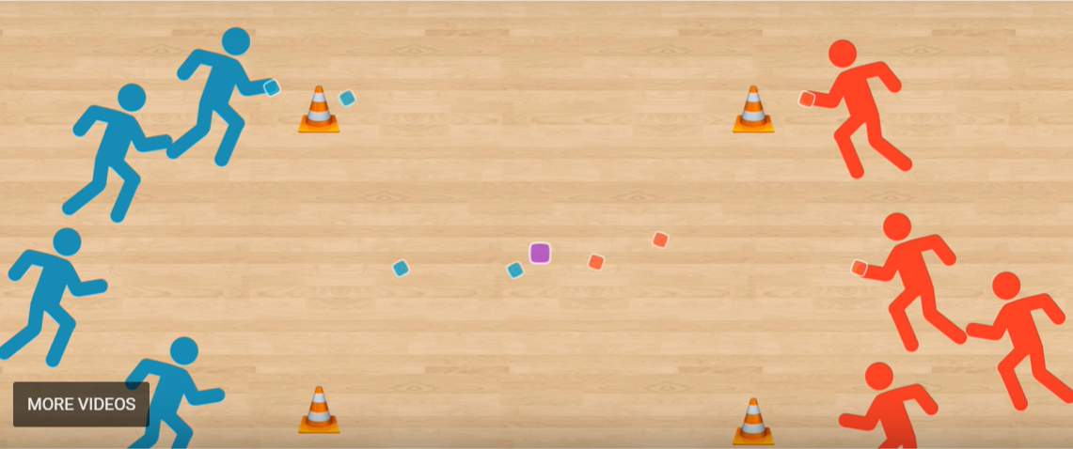
4 Reflection:
What did I learn today?
What did I do well?
What could I improve on?
How could I use ________________ at school or on the weekend?

